**Competition to Competence**

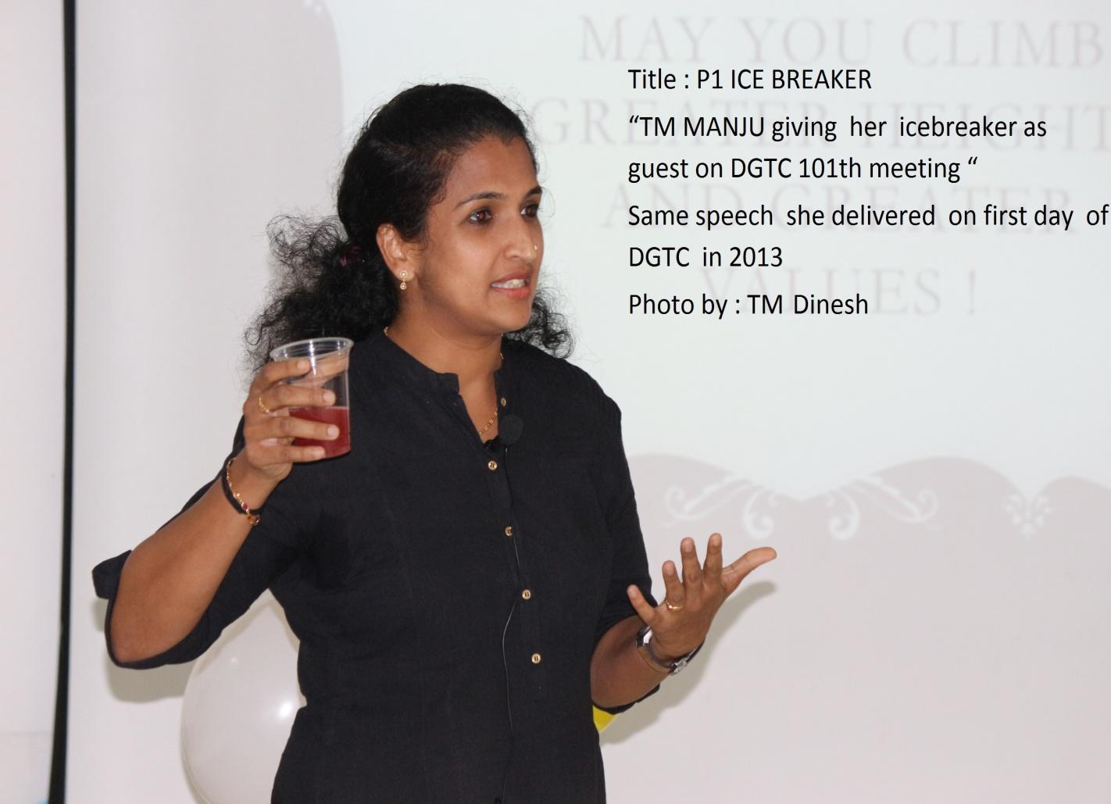

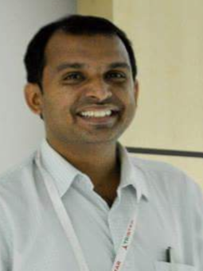**Dinesh Kumar. N**

**Discovery Gardens Toastmasters Club**

**Winner – Best Capture (Member) Divn F PR Contest**

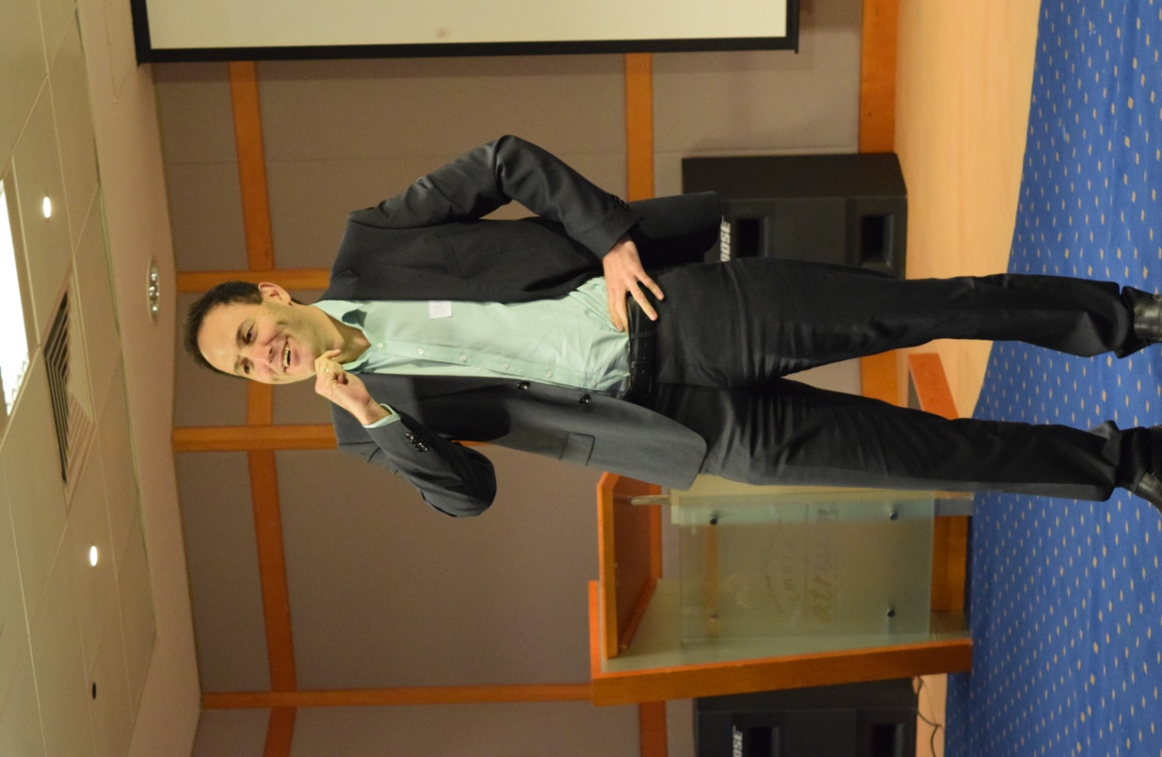



**TM Chathanya Krishnakumar**

**Emirates Toastmasters Club**

**Runner Up – Best Capture (Member) Divn F PR Contest**

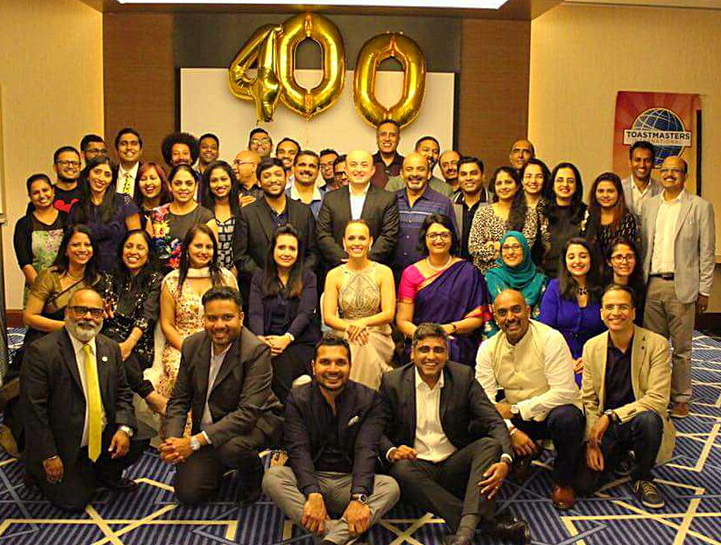

**VP-Public Relations**

**Emirates Toastmasters Club**

**Winner – Best Capture (club) Divn F PR Contest**

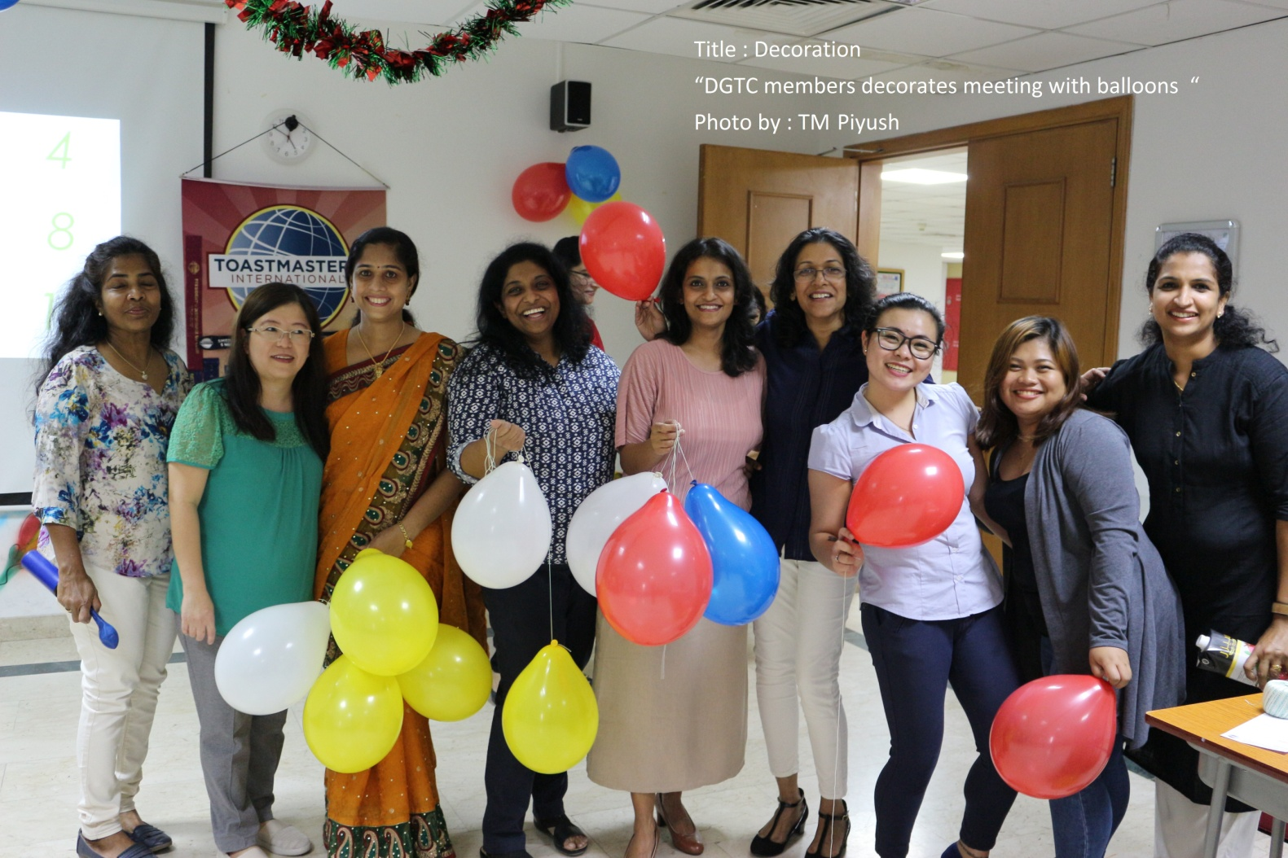

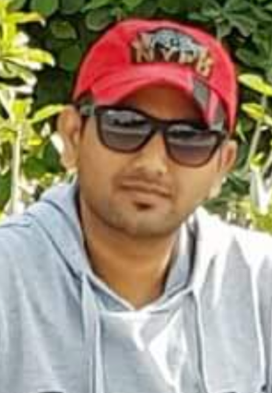**TM Piyush VP-PR**

**Discovery Gardens Toastmasters Club**

**Runner Up – Best Capture (club) Divn F PR Contest**